DAD-220 Milestone 3

Collins, Garrett

Southern New Hampshire University

TASK 1

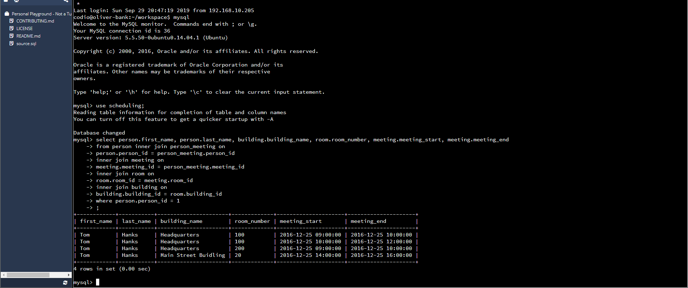

|  |  |
| --- | --- |
| **Code** | **Reasoning** |
| SELECT person.first_name, person.last_name, building.building_name, room.room_number, meeting.meeting_start, meeting.meeting_end | This code is used to “SELECT” all of the data from the specified columns that are the same in both tables and is setup to inner join from other tables as follows… |
| From person inner join person_meeting on person.person_id = person_meeting.person_id | This code joined the person table and the person_meeting table with the foreign key constraint in common of “person_id”. |
| Inner join meeting on meeting.meeting_id = person_meeting.meeting_id | This code is also determining that the same column meeting_id in both tables are being joined from tables “meeting” and “person_meeting”. |
| Inner join room on room.room_id = meeting.room_id inner join building on building.building_id = room.building_id | This code is joining “room_id” column from tables “room” and “meeting”, as well as joining column “building_id” from tables “room” and “building”. |
| where person.person_id = 1; | This code is specifying that we are to find all the meetings that Tom Hanks has to attend, in which we know his person_id is 1 in the table “person”. |

TASK 2

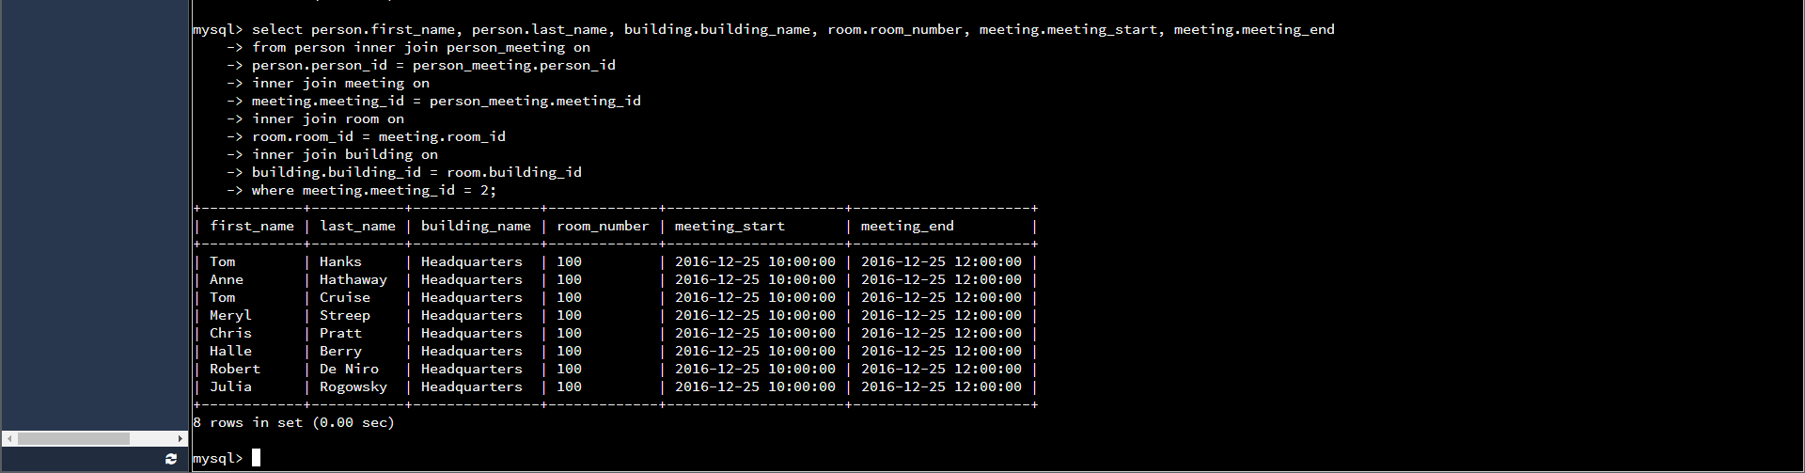

|  |  |
| --- | --- |
| **Code** | **Reasoning** |
| SELECT person.first_name, person.last_name, building.building_name, room.room_number, meeting.meeting_start, meeting.meeting_end | This code is used to “SELECT” all of the data from the specified columns that are the same in both tables and is setup to inner join from other tables as follows… |
| From person inner join person_meeting on person.person_id = person_meeting.person_id | This code joined the person table and the person_meeting table with the foreign key constraint in common of “person_id”. |
| Inner join meeting on meeting.meeting_id = person_meeting.meeting_id | This code is also determining that the same column meeting_id in both tables are being joined from tables “meeting” and “person_meeting”. |
| Inner join room on room.room_id = meeting.room_id inner join building on building.building_id = room.building_id | This code is joining “room_id” column from tables “room” and “meeting”, as well as joining column “building_id” from tables “room” and “building”. |
| where meeting.meeting_id = 2; | This code is specifying that we are to find all the people that are attending meeting ID 2. |

TASK 3 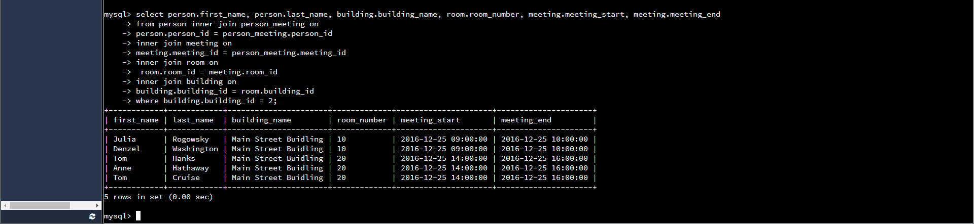

|  |  |
| --- | --- |
| **Code** | **Reasoning** |
| SELECT person.first_name, person.last_name, building.building_name, room.room_number, meeting.meeting_start, meeting.meeting_end | This code is used to “SELECT” all of the data from the specified columns that are the same in both tables and is setup to inner join from other tables as follows… |
| From person inner join person_meeting on person.person_id = person_meeting.person_id | This code joined the person table and the person_meeting table with the foreign key constraint in common of “person_id”. |
| Inner join meeting on meeting.meeting_id = person_meeting.meeting_id | This code is also determining that the same column meeting_id in both tables are being joined from tables “meeting” and “person_meeting”. |
| Inner join room on room.room_id = meeting.room_id inner join building on building.building_id = room.building_id | This code is joining “room_id” column from tables “room” and “meeting”, as well as joining column “building_id” from tables “room” and “building”. |
| where building.building_id = 2; | This code is specifying that we are to find all the people who have meetings in the Main Street building which we know has a building_id of 2 in the table building. |

TASK 4

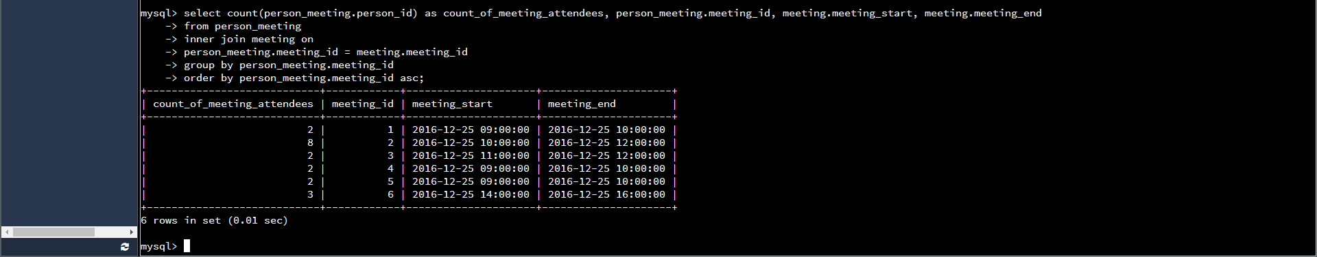

|  |  |
| --- | --- |
| **Code** | **Reasoning** |
| SELECT count(person_meeting.person_id) as count_of_meeting_attendees, person_meeting.meeting_id, meeting.meeting_start, meeting.meeting_end | This code is used to count the number of attendees for every meeting. |
| From person_meeting inner join meeting on person_meeting.meeting_id = meeting.meeting_id | This code joined the person_meeting table and the meeting table with the foreign key constraint in common of “meeting_id”. |
| Group by person_meeting.meeting_id  Order by person_meeting.meeting_id asc; | This aggregate function is used to group the meeting_id in ascending order. |

TASK 5

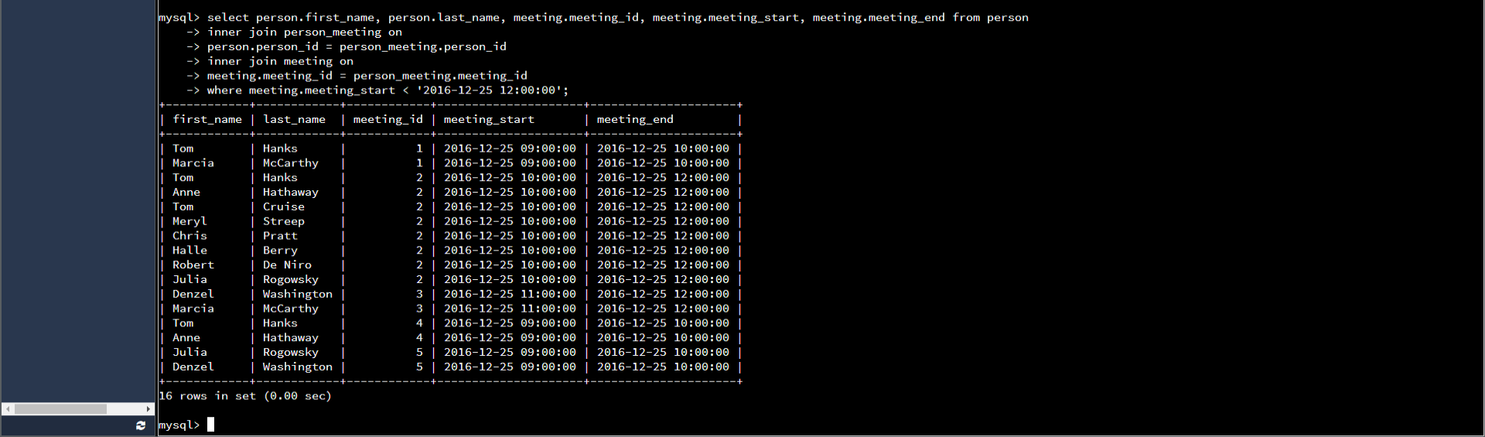

|  |  |
| --- | --- |
| **Code** | **Reasoning** |
| SELECT person.first_name, person.last_name, meeting.meeting_id, meeting.meeting_start, meeting.meeting_end | This code is used to “SELECT” all of the data from the specified columns that are the same in both tables and is setup to inner join from other tables as follows… |
| From person inner join person_meeting on person.person_id= person_meeting.person_id  Inner join meeting on meeting.meeting_id =  person_meeting.meeting_id | This code joined the person and the person_ meeting table with the foreign key constraint in common of “person_id”. Also joined is the meeting table with the foreign key constraint “meeting_id” in common with the person_meeting table. |
| Where meeting.meeting_start < ‘2016-12-25 12:00:00’; | This aggregate function is used to find all of the people that have meetings only before Dec. 25, 2016 at noon using INNER JOINs. |